1. **Once Application Started**

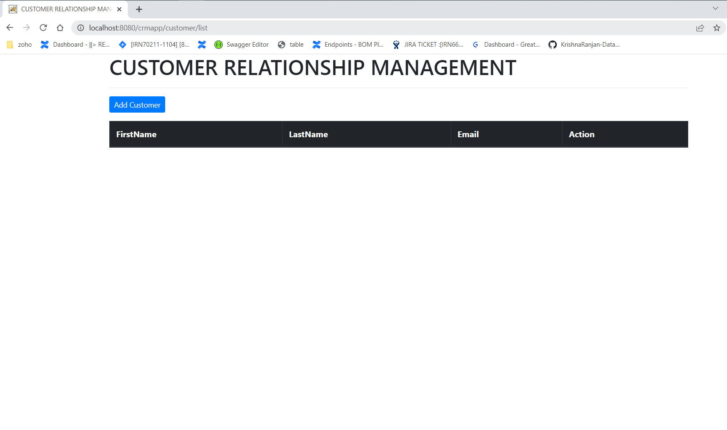

1. **After clicking on Add Customer**  
   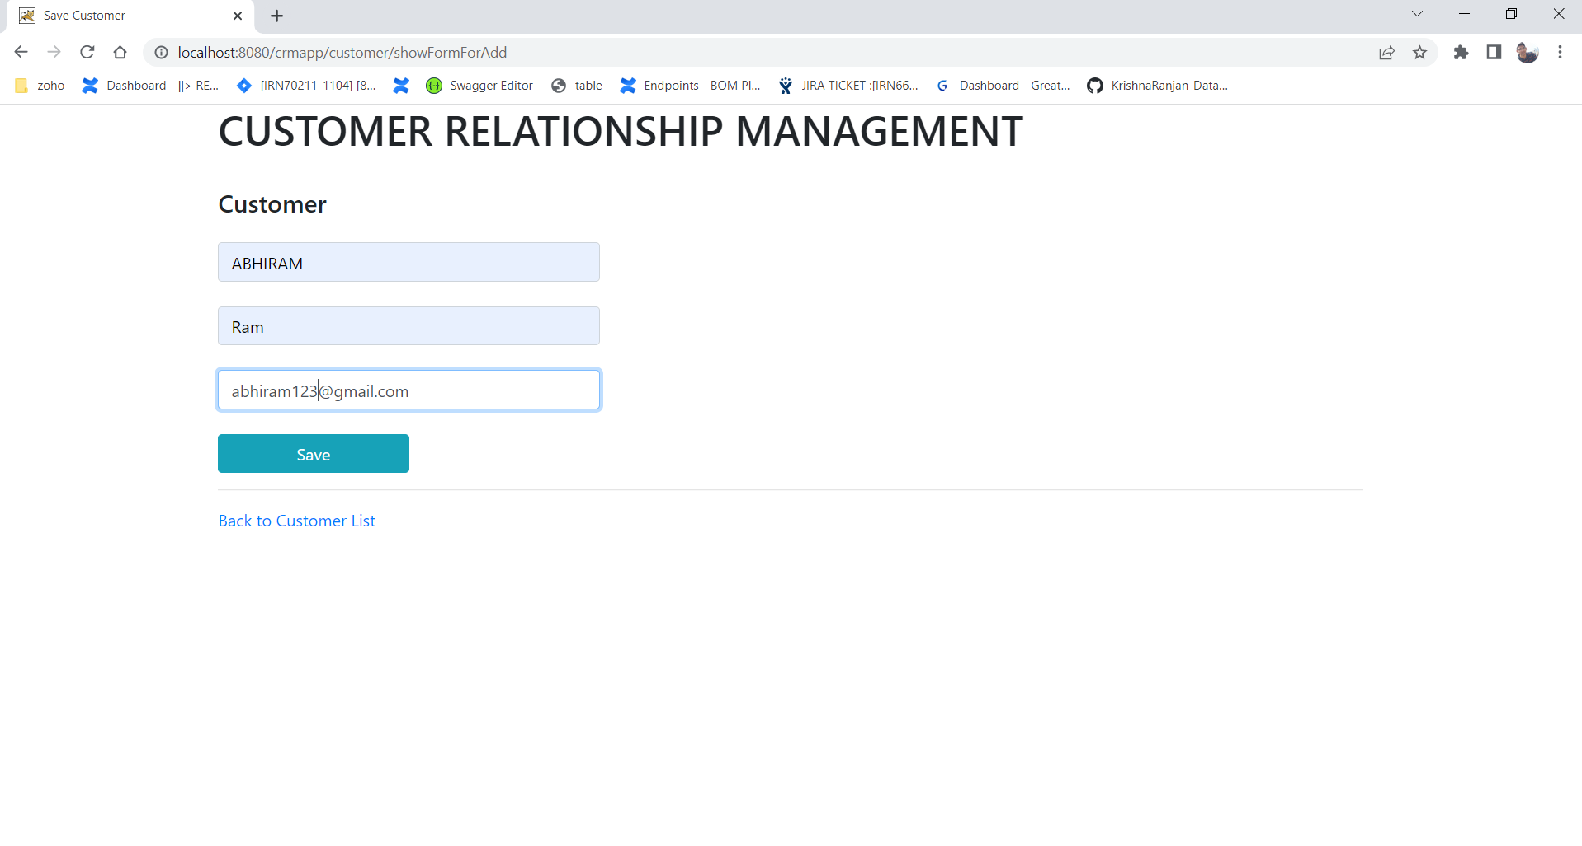
2. **After Clicking Save Button**

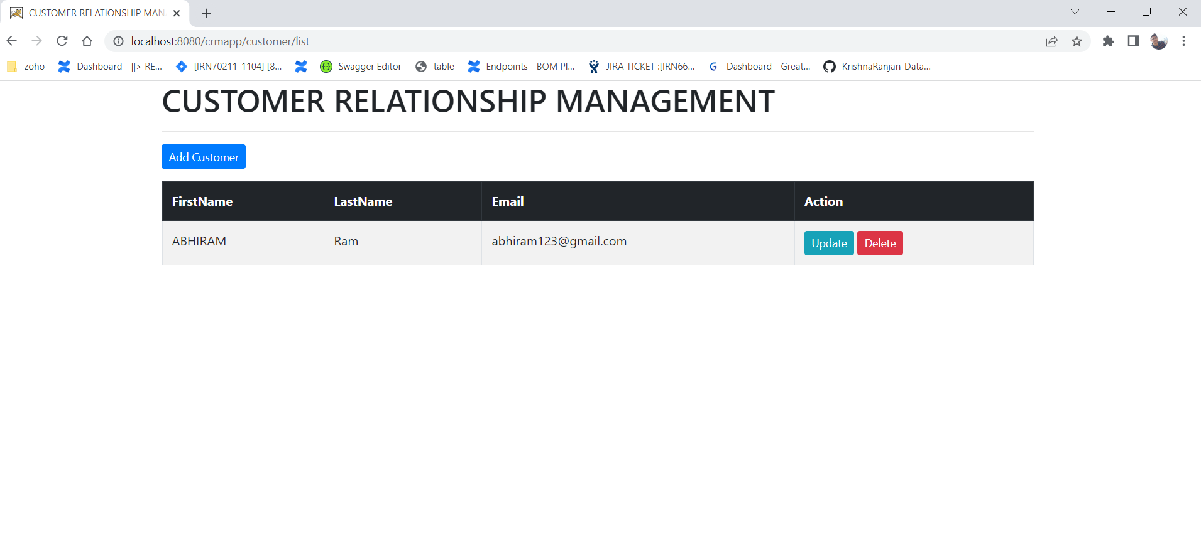

1. **After Adding few customers**

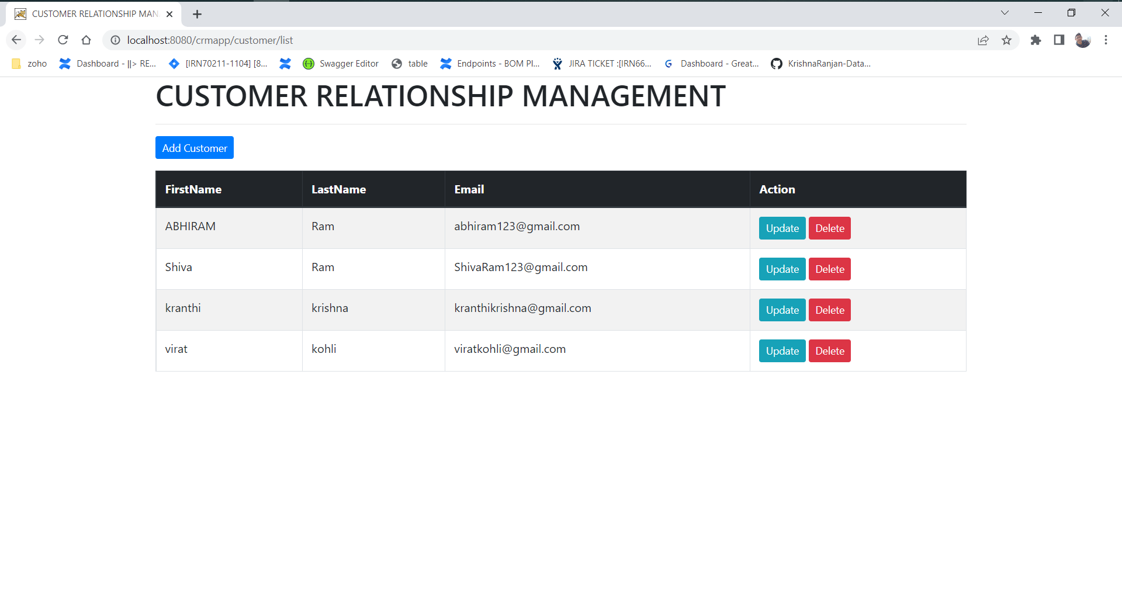

1. **Updating first row lastname by clicking Update button and Save**

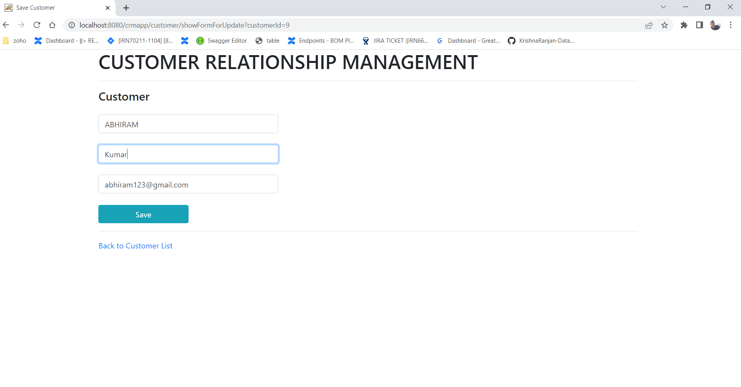

**After Updating the lastName changed from Ram to Kumar**

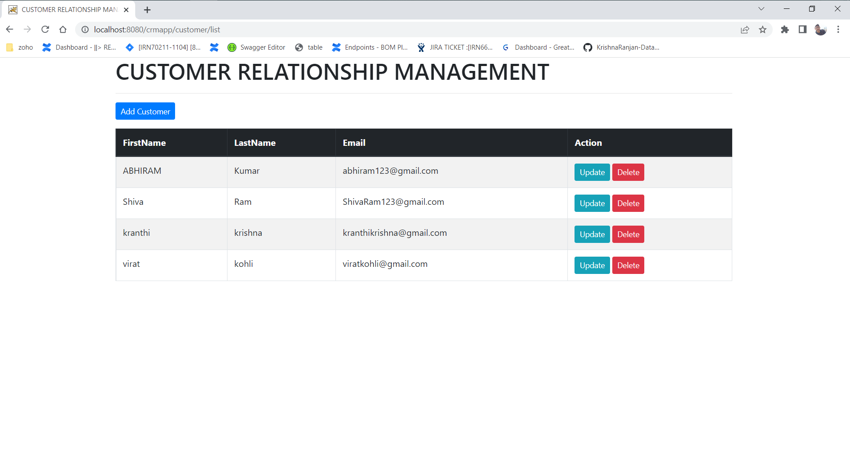

1. **Once clicking on Delete button, It will display warning message**

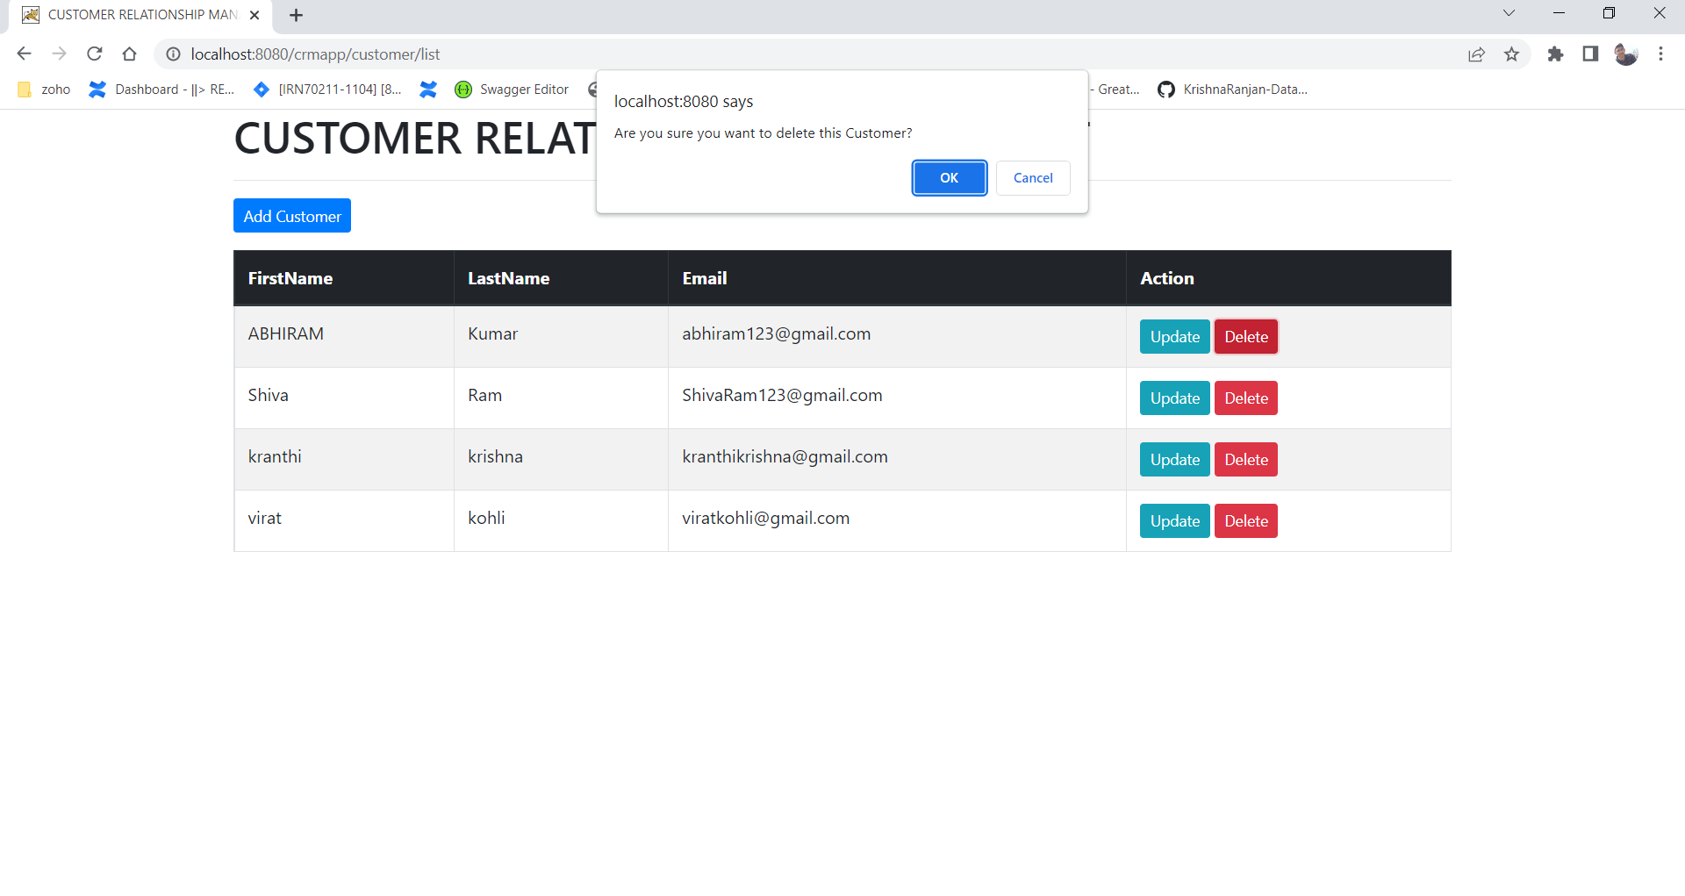

**If clicking on cancel it won’t delete the row  
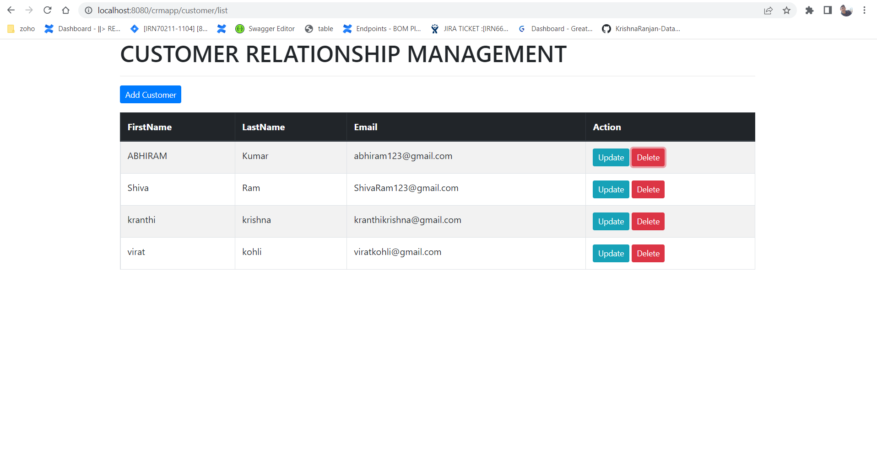**

**If we click Ok , The specific row will be deleted(Deleting first row), After Deleting row will be removed from Database  
